**LAB Assignment 3**

**Objectives: To familiarize with BETWEEN operator, SQL Wildcard (LIKE operator), GROUP BY , HAVING clause to group results**

1. Find information of all employee whose extension starts with ‘x2’ and employee number between 1200 and 1500. (Employees table)

**Source code**:

select * from employees where extension like 'x2%' and employeeNumber between 1200 and 1500;

**Screenshot:**



1. Find the sum of quantity in stock for different categories of productline from product table.

**Source code:**

select productLine,sum(quantityInStock) from products group by productLine;

**Screenshot:**

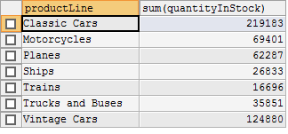

1. Determine the total number of orders for status (‘Cancelled’, ’Disputed’, ’In Process’, ’On Hold’). (order table)

**Source code:**

select status,count(status) from orders where status='Cancelled' or status='Disputed' or status='In Process' or status='On Hold' group by status;

**Screenshot:**

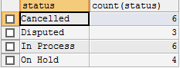

1. Determine the number of employees as per the job title. (employees table)

**Source code:**

select jobTitle,count(*) from employees group by jobTitle;

**Screenshot:**

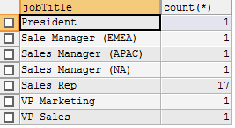

1. Find the customer numbers with sum of amount of payment is greater than 200000. (payments table)

**Source code:**

**Screenshot:**

1. List the name of cities where customer number is greater than 2. (customers table)

**Source code:**

select city from customers where customerNumber> 2;

**Screenshot:**

